Cornwall Primary Care
Training Hub
Course Prospectus
April 2026

Multi-Professional Training
for Primary Care Teams

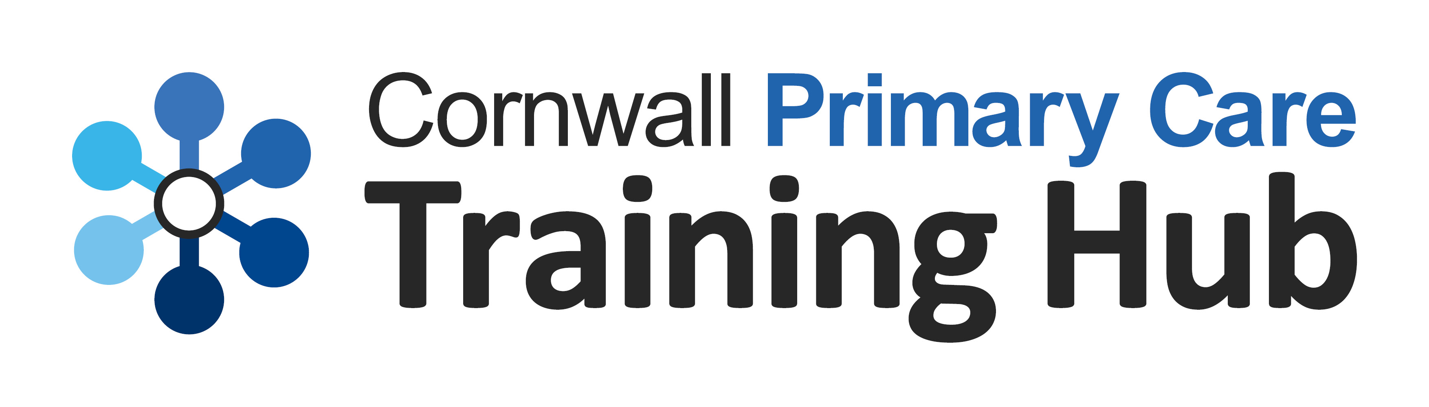

Welcome to the Cornwall Primary Care Training Hub

1 | Bladder and Bowel Health
2 | Business Support
3 | Cancer
4 | Cardiovascular
5 | Clinical Assessment and Diagnostics
6 | Diabetes
7 | Diet, Nutrition and Weight Management
8 | End of Life Care
9 | Immunisation
10 | Medicines Management
11 | Mental Health
12 | Musculoskeletal
13 | Older Person Care
14 | Paediatrics
15 | Personalised Care
16 | Primary Care Access
17 | Public / Population Health
18 | Respiratory
19 | Sexual / Reproductive Health
20 | Teaching and Research
21 | Tissue Viability
22 | Chronic Kidney Disease
23 | Connect and learn

This prospectus details the range of courses we offer. Visit our Education Programme webpages for course dates and booking.

Multi-Professional Clinical Training
Most courses can be accessed by any practice team members, irrespective of discipline. We deliver our courses either face to face or virtually and signpost to relevant e-learning / resources.

Where it is not immediately evident to whom courses are aimed, we have used a colour coding system to help individuals to identify the level of the course:
● Entry
● Intermediate
● Advanced

Business Support Training
We provide an extensive programme of business support training. These courses are available to all staff within primary care whether you have a clinical or business support role. For further details, please go to our website or view our Prospectus for Business Support Training.

Funding
The Education Programme is mainly funded by the primary care subscription with the use of alternative funding steams to supplement programme development and delivery. There is also individual training place purchase and support from the pharmaceutical industry where appropriate.

For updated information, further study opportunities, resources, and support, ensure you receive our fortnightly Training Hub General Practice Bulletin.
For all enquiries please contact:
kernowhealthcic.workforce@nhs.net

Navigate our programme using…

Role Development Pathways
Our role development pathways are designed to help embed newly emerging multi-professional roles and pathways, alongside the well-established roles. The following pathways have been developed.
- Health Care Support Worker
- Practice Nurse Preceptorship
- Practice Nurse
- First Contact Practitioner
- Advanced Practitioner
- Personalised Care and Wellbeing Roles
- Administrative and Managerial Roles
- GP & GP Trainee

Primary Care Role Development Pathways

Clinical Training Roadmaps
Our roadmaps provide you with an ‘at a glance’ look at the educational offers by clinical area or role. If you are new to a clinical area, have a look at the education available under our ‘Getting Going’ section! As you build your skills and experience, move onto ‘Journey Progression’ and ‘Onward Journey’ for those who are seeking more advanced-level training. Please use the link to our education pages for further details.
- Diabetes Training Roadmap
- Respiratory Training Roadmap
- Women’s Health Training Roadmap
- Cardiovascular Training Roadmap
- Health Care Support Worker Roadmap
- Education Programme – Kernow Health | Keeping General Practice at the heart of patient care - Kernow Health | Keeping General Practice at the heart of patient care
- Bladder and Bowel Health

We signpost to the following courses provided by Cornwall Foundation Trust.

● Bowel Dysfunction in Adults
● Developing Confidence in Catheterisation
● Continence Awareness

2. Business Support
1

We provide an extensive programme of business support training. These courses are available to all staff within primary care whether you have a clinical or business support role. For further details, please go to our website or view our Prospectus for Business Support Training.

3. Cancer

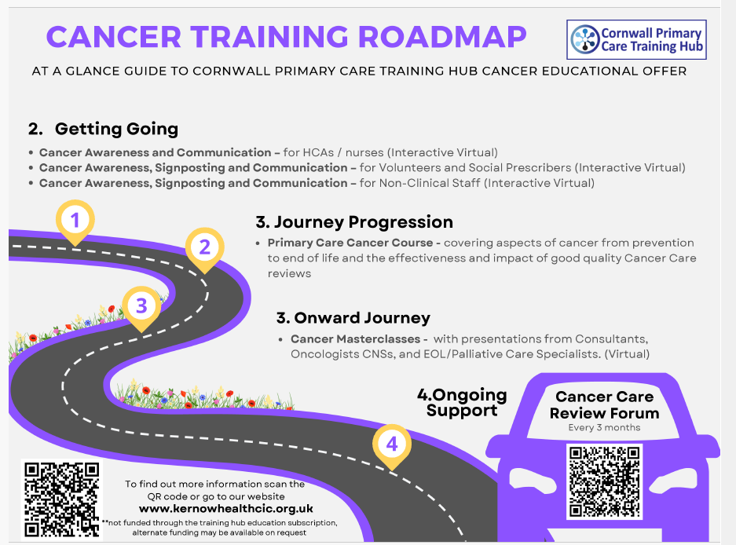

● ● Cancer Awareness, Signposting and Communication (virtual)
This session is for HCAs, NAs and newly qualified Treatment Room and Practice Nurses. The session provides the opportunity to increase understanding and awareness of their role in cancer screening and prevention.

● ● ● Cancer Care Reviews in Primary Care – Support and Education Forum (virtual)
This forum provides the opportunity for all staff undertaking cancer care reviews to learn together. Those new to their role and experienced can come together on a regular basis to share best practice. The forums will provide the opportunity to:
- Share best practice for three month and annual cancer care reviews.
- Learn from each other and listen to expert speakers sharing their top tips.

● ● ● Cancer Masterclass (virtual)
Open to all those working in Primary Care in Cornwall. Join this interactive masterclass with presentations from Consultants, Oncologists CNSs, and EOL/Palliative Care Specialists. This is a virtual opportunity for networking and supporting PCN staff with cancer education.

● ● Primary Care Cancer Course (face to face and virtual)
The course looks at all aspects of cancer from prevention to end of life. It looks at the effectiveness of good quality cancer care reviews and how improved ways of working in primary care can improve patient outcomes and reduce the demand on health resources. Delivery of this course is by Consultants, CNSs and other members of the cancer services team at RCHT via 3 full days face to face AND 3 half days virtually. This course is open to all health professionals.

Cancer Additional Educational Resources and Training

4. Cardiovascular Training

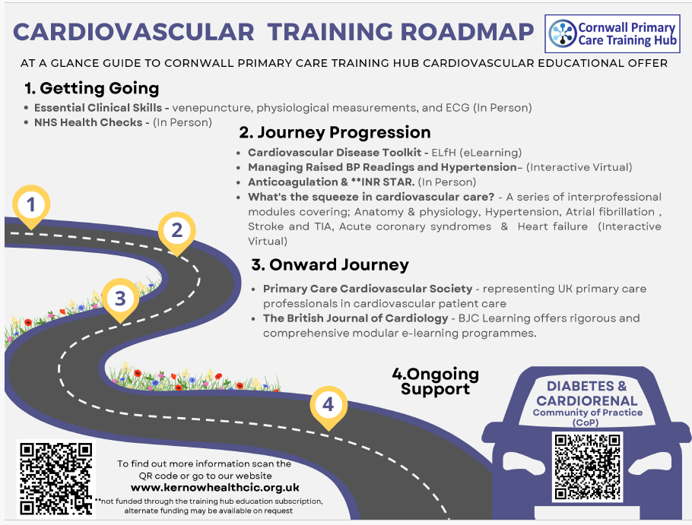

● ● ● What’s the squeeze in Cardiovascular Care? (virtual)

A series of modules aimed at both registered and non-registered health care professionals, covering:
- anatomy and physiology
- ECG
- hypertension
- atrial fibrillation
- prevention, cause and management of stroke and TIA
- acute coronary syndromes
- heart failure

The modules are underpinned by a set of competencies. On completion the learner will have developed a foundation of knowledge to enable them to complete a review of patients at their own level of practice.

● ● Management of Anticoagulant Therapy (face to face)
This training will be for practice nurses and health care support workers for the management of anticoagulation. This session will focus on:
- Anticoagulation including DOAC, warfarin and INR management.
- Point of care testing and best practice from the lab perspective.
- Signposting to self-directed INR star learning.

Blood Pressure and Hypertension (virtual)
● This training is aimed at Health Care Assistants and entry level Nurses to enable them to gain an understanding of the importance of hypertension management in general practice and feel more confident in their delivery of this service, thus ensuring that patients receive the best and most up to date advice.

Diabetes and Cardiorenal Community of Practice (virtual) every other month
This Diabetes and Cardio-Renal community of practice will provide an opportunity for practice nurses in Cornwall to join on a regular basis and engage in both peer and specialist nurse support

Link to the Community of Practice Page

Cardiovascular Additional Educational Resources and Training

5. Clinical Assessment and Diagnostics

● Essential Clinical Skills (face to face)
This is a two-day essential skills course that covers the fundamentals in physiological measurements, ECG recording and venepuncture. This course is designed for health care assistants working in primary care and nursing homes, as well as registered nurses who might need a refresher. It is ideal as an entry level course for staff who need to develop their basic clinical skills to deliver safe and quality care to patients.

● Interpretation of Common Blood Test Results Programme (virtual)
We are delighted to offer a comprehensive programme of learning around the ordering and interpretation of blood tests in the community. These sessions are for registered professionals. This programme is delivered via 7 x half day sessions covering:
- Introduction
- Microbiology
- Full blood count, clotting, inflammatory markers
- Kidney function, including AKI
- Liver function and lipids
- Hormones, thyroid and diabetes
- The ECG

Venepuncture (face to face)
The provision of skills training for obtaining venous blood samples from the arm. This course provides theory and practice to gain competence, under clinical supervision of a practitioner in your workplace.

● ● Verification of Death (provided by CFT)
The overall aim of the session is to educate, train and assess registered nurses in verifying death, by underpinning it with a base knowledge of the law (national and local policies).
● ● Ear, Nose and Throat (ENT) Skills Session
We are excited to offer a brand-new, face-to-face training course designed specifically for practice staff looking to enhance their confidence and competence in ear, nose and throat (ENT) assessments.
This interactive course focuses on developing core practical skills in ear examinations, as well as the assessment of common nose and throat conditions. Participants will gain hands-on experience in a supportive learning environment, enabling them to refine their technique, improve diagnostic accuracy, and strengthen clinical decision-making.
● ● Diagnostic Testing and Long-Term Conditions
We are pleased to introduce a new face-to-face training course designed to enhance the use of diagnostic testing in the care and management of patients with Long Term Conditions (LTCs).
This engaging and practical course will support primary care practitioners in developing a deeper understanding of how diagnostic tests can be effectively used to inform clinical decision-making. It will explore the role of testing in diagnosing, monitoring, and managing a range of long-term conditions, helping clinicians deliver more accurate and timely care.

Clinical Skills.Net
The Training Hub has purchased licences for primary care staff to access Clinical Skills.net, an online clinical procedures manual/educational resource to support training and best practice. This provides more than 350 clinical procedure guides presented in a clear, illustrated step-by-step format, aligned with current best practice and fully referenced.

Guide to Taking Group and Screen Blood Tests in General Practice
Accurate blood sample labelling is crucial in general practice, especially for Group and Screen (G&S) tests. Due to a high volume of errors in labelling G&S samples, many have been rejected by the lab, leading to inconvenience for patients and possible delays to treatment. Our comprehensive guide ensures that healthcare workers can efficiently and correctly take and label G&S blood samples. The link below will take you to the RCHT resource on labelling Group and Screen samples which should be downloaded.
Guide to Taking Group and Screen Blood Tests in General Practice – Kernow Health | Keeping General …

6. Diabetes Training

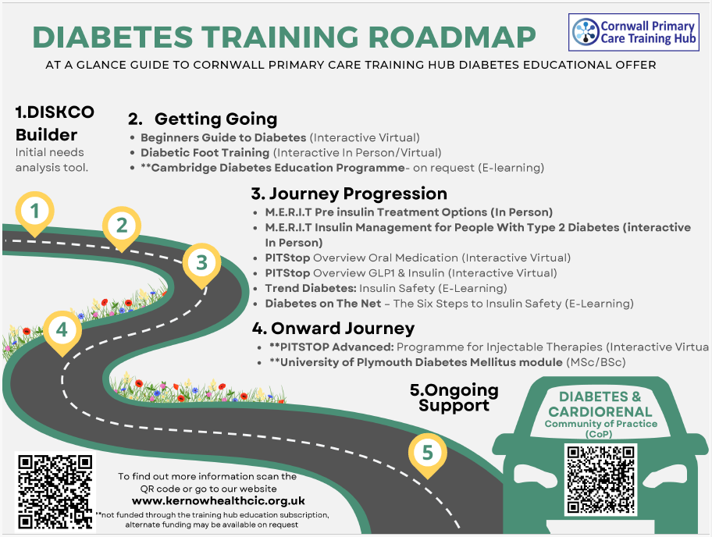

● ● ● Primary Care Diabetes Skills & Confidence (DiSkCo) Builder
This offers individuals, teams, and networks a comprehensive tool to assess diabetes competencies for each member of staff delivering the diabetes clinical service. The tool links to relevant training options to close competency gaps. It provides a simple route to identifying and meeting upskilling needs for PCN diabetes services. For further information contact emma.borders@nhs.net

● Beginner’s Guide to Diabetes (virtual)
This training supports development of new models of care delivery and is particularly suitable for health care support workers and registered professionals new to diabetes who are becoming more involved in delivering diabetes care. It covers foundational knowledge of what diabetes is as well as covering all components of annual review and essential aspects of person-centered care in diabetes.

● ● ● PITstop Oral Diabetes Medication Overview (Virtual Learning)
This 90-minute session will provide an overview of oral diabetes medications and individual HbA1c and blood glucose target setting. This will include an overview of the updated NICE NG28 type 2 diabetes in adults treatment algorithms.
This session is suitable for practice nurses, advanced nurse practitioners, community nurses, clinical pharmacists, paramedics, GPs and GP trainees who are involved in diabetes provision, looking for an update.
This live session will be delivered virtually by PITstop for Diabetes.
● ● PITStop GLP-1 Agonists and Insulin Overview (Virtual Learning)
This 90 minute session, will cover:
- when to consider an injectable therapy as part of the treatment regimen
- which are used and why (GLP-1 Agonists / insulin)
- some top tips for people with type 2 diabetes already on insulin
This training is for all professionals who have completed a foundation level diabetes course (including CDEP e-learning).
●PITstop Continuous Glucose Monitoring. 4.5 hour virtual learning
A course for practitioners who initiate and titrate insulin and GLP - 1s.

● ● ● Diabetes & Cardiorenal - Community of Practice (virtual)
Running virtually on a bi-monthly basis, this community of practice will provide an opportunity to join together on a regular basis and engage in both peer and diabetes specialist nurse support. Guest speakers and sponsors may also be in attendance, so the sessions are extremely valuable.

● Diabetic Foot Training (face to face / virtual)
This training, delivered by the local specialist podiatry team, provides an overview of diabetic foot disease, how to identify the ‘at risk’ foot and who, when and where to refer. It is particularly appropriate for HCA’s/technicians undertaking foot screening in diabetes.

● ● ● Cambridge Diabetes Education Programme E-Learning

This is a competency-based programme with multiple topics which individuals can select. The programme offers competency assessment with accompanying resources to support knowledge of relevant national and international clinical guidelines.

Please contact kernowhealthcic.workforce@nhs.net for access.

There are valuable nationally recognised resources on the link below.

Diabetes Additional Educational Resources and Training

7. Diet, Nutrition and Weight Management

The following link takes you to valuable learning materials from BAPEN and Cornwall Health Library including e-learning for health regarding eating disorders for GPs and Primary Care Clinicians.

Diet Nutrition and Weight Management – Educational Resources and Training

8. End of Life Care

● ● ● Enhancing Confidence in End-of-Life Care - In person training by Cornwall Hospice Care

Caring for people approaching the end of life requires clarity, confidence and compassion. This focused half-day workshop is designed to support all practice staff in recognising when patients may be entering the final phase of life and responding with sensitive, person-centred care.
This workshop is ideal for staff involved in supporting people with progressive, life-limiting conditions, including non-clinical staff who may be talking to patients or families on the phone or in the surgery.
What you’ll gain
- Greater confidence in recognising end-of-life situations.
- Practical tools to support clinical decision-making.
- Improved communication skills for sensitive conversations.
- A clearer understanding of how to support personalised, dignified care.

End of Life Care – Educational Resources and Training

This resource, developed by the Community Specialist Palliative Care Nurse in West Cornwall, supports understanding of symptom control using subcutaneous medications at the end of life. It is designed for registered health care professionals involved in the delivery, administration, or prescribing of subcutaneous medicines during end-of-life care.
The Cornwall & Isles of Scilly End of Life Learning Path is accessible to the entire health and social care workforce. It has been created to guide and support staff working across primary, secondary, and social care settings, ensuring a consistent and evidence-based approach to end-of-life education.
The electronic learning path is complemented by a hand-held passport, offering a practical tool for reflection, discussion, and recording evidence of learning. Alongside this, a programme of locally delivered sessions provides further opportunities for skills development and professional support.

9. Immunisation, Vaccination and Medication

Our immunisation training programme is interprofessional, to incorporate the many different healthcare workers in primary care who can now participate in immunisation. All immunisation training staff should ensure that their anaphylaxis skills and Hepatitis B vaccination is up to date.

● ● Immunisation Foundation (Interprofessional) (face to face)
The Foundation Immunisation training is intended for health care professionals, who will be administering vaccines within a primary care setting, including those in the childhood vaccination programme. The training programme consists of e-learning provided by E-Learning for Health, followed by attendance at an interactive seminar.

● ● Immunisation Update (Interprofessional) (face to face / virtual)
The interprofessional immunisation update will cover the following topic areas will be covered:
- Current issues in immunisation (with a particular focus on Influenza & Covid)
- Recent epidemiology of vaccine preventable disease
- Any changes to vaccine recommendations or national policy
- Update on vaccine ordering, storage and administration
- Any changes to legislation relevant to vaccination
- Review of current practice, recent vaccine incidents and identification of areas for improvement
- Interactive activities centred around problems encountered in practice.

● ● Introduction to Travel Health (face to face)
Are you interested in expanding your practice and developing your skills in the exciting and dynamic specialist area of Travel Health? This 2-day, face to face, course is designed for practice nurses not currently practicing travel health but interested in gaining a basic understanding of what is required to carry out a safe and effective consultation. It will also help with decision making regarding vaccines and malaria advice.

● ● Update in Travel Health (virtual)
This course is designed for those working within primary care who have completed travel immunisations in the past and who require an update. It will provide an update in travel medicine, covering recent outbreaks and hot topics in travel health. The second session will provide the opportunity for delegates to engage in case study consultations and discuss with their peers.

● Vitamin B12 Deficiency
A self-directed workbook and video, serving as an educational resource and a means to demonstrate competency in the theory and practical skills necessary for vitamin B12 administration. It is designed as an “open book” knowledge update, allowing learners to read and familiarise themselves with best practices in vitamin B12 administration and stay current in their knowledge.
● ● ● Iron Deficiency in Primary Care
Iron deficiency is common but often under-recognised, particularly when it occurs without anaemia. This 90-minute webinar will explore the physiology of iron metabolism, key risk factors and causes of deficiency, and the range of clinical presentations that may occur. The session will also review appropriate investigation and evidence-based management of iron deficiency in primary care, supporting clinicians to recognise and manage the condition earlier within routine practice

Immunisation Additional Educational Resources and Training

10. Medicines Management

● Non-Medical Prescribing Update (face to face)
This course is for staff who are non-medical prescribers working within primary care.
The study session will be delivered with a clinical supervision ethos, where case studies can be discussed and debated, and clinicians can work collaboratively within action learning sets.

11. Mental Health

The following link will take you to useful resources from Healthy Cornwall, the Mental Health Awareness programme from e-learning for Health. There is also access (when requested) to a training programme that equips infant, children, and young people’s intervention staff to address a wide range of emotional, social, wellbeing and mental health challenges.

We will also be offering 45-minute sessions on a variety of Mental Health related topics which will be delivered by a Mental Health Practitioner. These will be circulated once confirmed.
Mental Health –Educational Resources and Training

12. Musculoskeletal

● Hip and Knee Osteoarthritis (OA) – Changing Perspectives (virtual)
This 2-hour session, delivered via MS Teams, is aimed at GPs and other primary care clinicians who manage patients with osteoarthritis (OA). Primarily, the training will focus on improving diagnosis and management of hip and knee OA in primary care and will aim to improve alignment to NICE guidelines for diagnosis and management. The training will be aimed at improving knowledge of OA and developing greater confidence

13. Older Person Care

● ● ● Dementia and Delirium Training (face to face / virtual)
This study day, open to health and social care staff, covers:
- Dementia awareness
- Dementia identification
- Dementia risk reduction and prevention
- Person centred dementia care
- Communication, interaction, behaviour in dementia care
- Health and well-being in dementia
- Pharmacological interventions and dementia
- Living well with dementia care
- Families and carers as partners in dementia care
- Equality, diversity, and inclusion in dementia care
- Law ethics and safeguarding in dementia care
- End of life dementia care
- Research and evidence-based practice in dementia care

Please do check the valuable additional resources on the link below including an assessment tool kit for Primary Care Practitioners.

Older Person Care – Additional Educational Resources and Training
Dementia – Additional Resources

14. Paediatrics

● Assessment and Management of the Ill Child (virtual)
The training uses case-based scenarios to consider common conditions, such as: fever, ENT, otitis media, respiratory illness, croup/RSV/pneumonia, UTI, bowel dysfunction, D+V, rashes, orthopaedic issues.

● Paediatric Asthma (virtual)
This course will cover the epidemiology and impact of childhood asthma, the latest asthma guidance with regards to both diagnosis and treatment.

15. Personalised Care

● ● ● Coaching Conversations (face to face)
The NHS long term plan talks about a shift in the relationship with the people we support, hence we need new skills for a new kind of relationship. Instead of treating patients as passive recipients of care, they must be viewed as partners. A coaching approach enables a culture of encouraging people to be resourceful and focuses on intrinsic and extrinsic motivators. This 2-day accredited training enables participants to understand how coaching can be used effectively within a clinical or professional role, examining not only how to coach conversation skills, but also looking at when and where a coaching approach is effective.

● ● ● Personalised Care and Support Planning Programme
A practical, interactive workshop to deepen your personalised care skills—covering outcome development, person-centred conversations, and real-time practice with peers.

● ● ● Women’s Health in Practice – Better Health Outcomes Training

A 3.5-hour practical, interactive training exploring gender and health outcomes, with space to reflect on professional practice, share experiences, and strengthen equitable care.

16. Primary Care Access

Passport to Primary Care
The Passport to Primary Care self-directed study guide is an asynchronous learning tool designed for healthcare workers new to general practice. This resource is intended to form part of the employer induction programme, providing an introduction to general practice. This programme includes interactive videos, self-directed study materials, and e-learning modules. The Passport to Primary Care self-directed study guide content will cover:

- commissioning, funding, indemnity and regulation
- scope of practice, lone working, consent, record keeping
- medicine management and the law
- personalised care and health coaching

17. Public / Population Health

Infection Prevention and Control Update for Primary Care (virtual)
Some of the IPC courses are currently on hold. They have kindly signposted us to the following resources in the meantime. These resources can be used whilst the IPC roles and responsibilities become more well established.
IPC page
The IPC team have fully endorsed the resources below and have promoted their use since the teams' inception.
Harrogate IPC resources

NHS Health Checks (face to face)
This training is aimed specifically at primary care staff delivering NHS Health Checks, suitable for those who are new to the programme as well as those who are looking for a refresher course. The training assumes you will already be competent to take a blood pressure, check for atrial fibrillation, measure height and weight.

Health Inequalities
We are planning to host a series of monthly health inequalities webinar training in conjunction with the Deep End Cornwall Network, with topics yet to be confirmed. Check our website for the latest details as they become available.
The link below will take you to the Population Wellbeing Portal which provides a central location for free training and education resources relating to the health and wellbeing of the public.
Here you will find links to e-learning, toolkits, videos, webinars and various publications.
Population Wellbeing - e-learning via E-Learning Health – Kernow Health | Keeping General Practice …

18. Respiratory Training

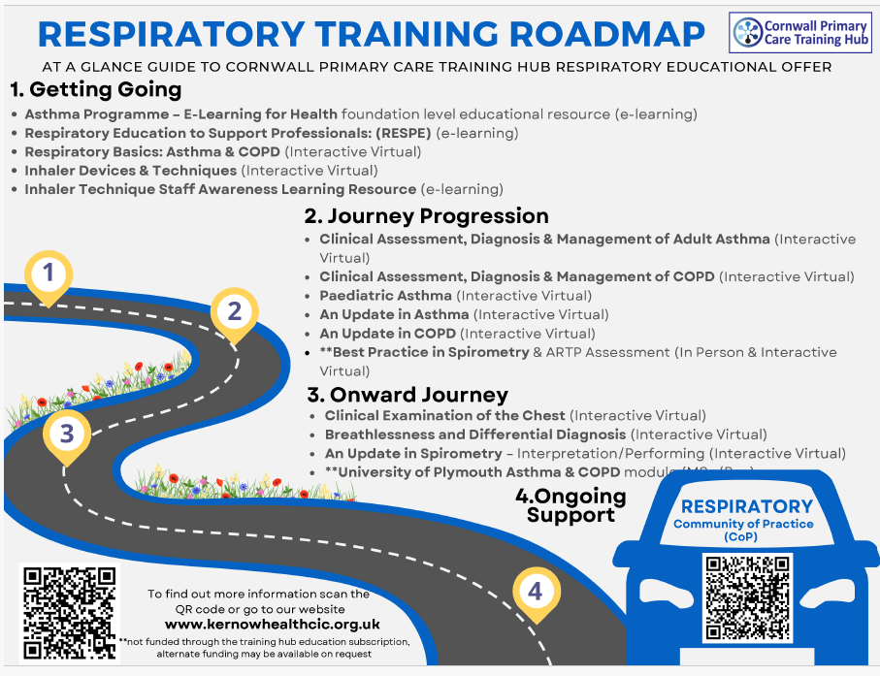

● ● An Update in Asthma (virtual)
This webinar is aimed at healthcare professionals that are already managing asthma patients in practice and are wanting an update.

● ● An Update in COPD (virtual)
This webinar is aimed at healthcare professionals that are already managing asthma patients in practice and are wanting an update.

● ● An Update in Spirometry – Interpretation (virtual)

This 2-hour standalone webinar is aimed at healthcare professionals that have already completed training in spirometry and are interpreting it in clinical practice and require an update.

● ● An Update in Spirometry – Performing (virtual)

This 2-hour standalone webinar is aimed at healthcare professionals that have already completed training in spirometry and are performing it in clinical practice and require an update.

● Clinical Examination of the Chest (virtual)

This webinar is aimed at registered healthcare professionals that are both new to listening to chests or those experienced and wanting an update.

● Clinical Examination of the Chest Part 2 - Breathlessness and Differential Diagnosis (virtual)
This webinar is for registered health care professionals who have completed the Clinical Examination of the Chest training and who wish to consolidate their learning further through case studies.

●● Clinical Assessment, Diagnosis & Management of Adult Asthma (virtual)
This course is suitable for healthcare professionals who are looking to enhance their knowledge and skills in asthma utilising the most up to date evidence-based guidance.

●● Clinical Assessment, Diagnosis & Management of COPD (virtual)
Suitable for healthcare professionals who wish to improve their knowledge and skills in COPD utilising the most up to date evidence-based guidance.

● ● ● Inhaler Techniques & Devices (virtual)

Aimed at healthcare professionals involved in the teaching and assessment of inhaler technique and those that prescribe or make respiratory treatment recommendations.

● Paediatric Asthma (virtual)
This course will cover the epidemiology and impact of childhood asthma, the latest asthma guidance with regards to both diagnosis and treatment.

● Respiratory Basics (Asthma & COPD) (virtual)
Facilitated by a Practice Nurse Specialist in Respiratory Care, this is a course for any healthcare professional beginning to work in respiratory care or who require an update. It covers the basics of Asthma and COPD and provides a good knowledge foundation.

● ● ● Respiratory Community of Practice (virtual)
Running virtually on a bi-monthly basis, this community of practice will provide an opportunity to join together on a regular basis and engage in both peer and respiratory specialist nurse support.

● ● Pathway to Best Practice in Spirometry ARTP Assessment (virtual)
This is designed for healthcare professionals who are responsible for performing, recording and interpreting spirometry and who wish to gain entry onto the ARTP register.
E-Learning for Health have some free training specifically around FeNO testing and interpretation which can be accessed below. These resources can be used in conjunction with the training sessions above.
Link to elfh - Understanding FeNO and performing the test
Link to elfh - Interpreting FeNO results
Please use the link below if you are interested in becoming a respiratory champion.
https://kernowhealthcic.org.uk/tbccourses/the-south-west-respiratory-champions-interest-register/
Respiratory Additional Educational Resources and Training

19. Sexual / Reproductive Health Training

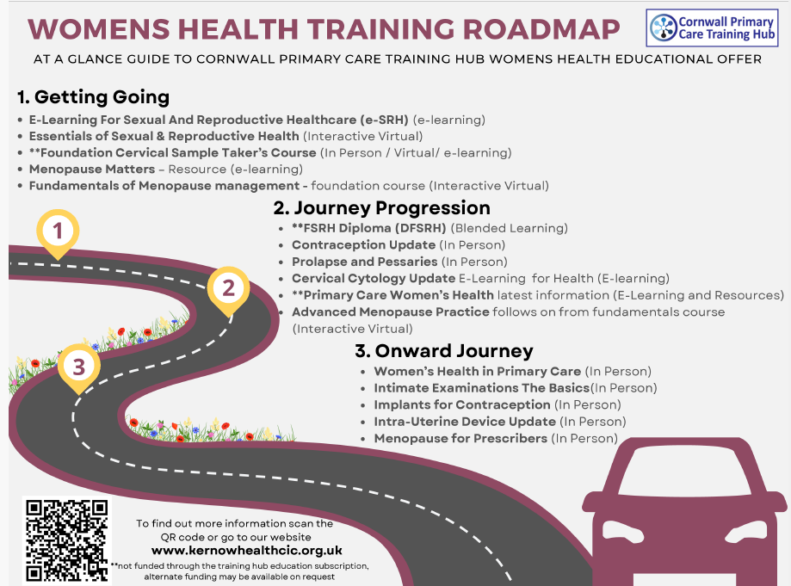

● ● Contraception Update (face to face)
This is a group session aimed at primary care clinicians who provide contraception advice and counselling. It will revise the principles of all recommendable methods and help you to guide women through the choices available to them.

● ● Essentials of Sexual & Reproductive Health (virtual)
This course, delivered by accredited trainer, provides updated information for current issues in sexual health, including contraception, sexually transmitted infections, HIV and teenage pregnancy. It is suitable for any Health Care Professional who has a role in delivering sexual health services.

● ● Foundation Cervical Sample Taker’s Course
This course is not included in the programme subscription and places must be purchased on an individual basis.
The aim of this course is to assist Cervical Sample Taker Trainees to maintain high standards of sample taking in accordance with local and national standards. Trainees are required to attend 2-day training before completing the rest of the programme by undertaking supported procedures in practice with their Mentor.

● Implants for Contraception (face to face)
Delivered by Dr Sarah Gray, this is a workshop aimed at those who are new to the provision of implants as well as existing or lapsed providers who wish to refresh.

● Intra-Uterine Device Update (face to face)
This session, delivered by Dr Sarah Gray, will cover options available, patient assessment and counselling, pain relief, fitting techniques, complications, follow up and troubleshooting, removal / replacement.

● ● Fundamentals of Menopause Management (virtual)
While the menopause is a natural stage of life, the fact that each women’s experience can be different, makes diagnosis, treatment, and management a complex area for clinicians. This session provides an overview of the fundamentals of menopause management for those new to the area, or those that may need a refresh. It is aimed at clinicians, particularly GPs, Nurses and AHPs.

● ● Advanced Menopause Practice (virtual)
This session is provided as a follow up to ‘Fundamentals of Menopause Management’ where common problems within menopause management will be explored, such as unscheduled / post-menopausal bleeding, use of progesterone, oestrogen and testosterone, breast cancer and family history of cancer.

● Menopause for Prescribers (face to face)
This session will cover physiology of menopause, patient assessment, what can be offered, prescribing HRT, review and problem solving and contraception in the perimenopause. There will also be the opportunity for Q&A.

● ● Prolapse and Pessaries (face to face)
This course is aimed at experienced nurses and GPs who are already competent to perform vaginal speculum examinations (e.g. smear takers). This session is suitable for both clinicians who do not currently fit and replace pessaries for prolapse, but who would like to do so, and, also, those who would like a refresher.

● ● Sexual and Reproductive Health Essentials (Virtual Learning)

Working with local trainers, The Cornwall Training Hub is excited to bring you this nationally recognised course.
Delivered virtually, Sexual and Reproductive Health Essentials for registered professionals is a one-day, entry level, interactive course for nurses working in primary care and other community settings. If you would like to build your knowledge and skills in sexual and reproductive healthcare, this course is for you.
The course is designed by the Faculty of Sexual and Reproductive health and can only be run by registered facilitators. Once you have completed the course, you will receive a certificate which is a nationally recognised qualification.
● ● Sexual Health in Primary Care (Virtual Learning)
Suitable for clinicians working in primary care, this 3-hour course is delivered by Sexual Health Nurse Practitioner in Primary Care, Alice Hobbs. Alice has worked in sexual health services for over 15 years and now provides sexual and reproductive health in Primary Care.

Sexual and Reproductive Health Additional Educational Resources and Training

20. Teaching and Research

If you’re interested in stepping into teaching and sharing your professional expertise, there are exciting opportunities to support you with this.

Starting October 2026 -Primary Care Facilitator Development Framework
Cornwall Training Hub is developing a Primary Care Facilitator Workforce Development Framework, offering quarterly masterclass sessions with expert speakers to help clinicians build skills in teaching, coaching, feedback and mentorship within primary care. More information can be found on our webpage:
This opportunity allows you to contribute to the development of learners across the sector, shaping their ongoing education and supporting the delivery of high-quality, evidence-based patient care. By becoming a facilitator, you play a direct part in strengthening standards and ensuring that knowledge and skills remain current and impactful

The links below will help you to navigate some of the teaching courses available that may be able to be accessed through CPD funding on request.

This link will take you to resources to help you with research and information about available teaching courses.

21. Tissue Viability

We signpost to the following courses provided by Cornwall Foundation Trust (CFT).

● Leg Ulcer Management (for HCAs)
● Management of Leg Ulcers Refresher course
● ● Practical Training for Leg Ulcer Management (for Registered Staff)
● ● Prevention of Pressure Ulcers
● ● Wound Care

The following link will take you to valuable resources form wound care today and E-Learning for Health. There are also educational resources from Urgo Medical relating to compression therapy including research papers. There are also videos linking to real life case studies to help inform your practise.

Tissue Viability Additional Educational Resources and Training

Please also see the link to the Cornwall Wound Formulary.
Cornwall Community (Primary Care and CFT) Wound Formulary

22. Chronic Kidney Disease

We are excited to be teaming up with Health Innovation Southwest and will soon be offering training sessions on a variety of topics related to this important area of care such as anatomy and physiology, risk factors, symptoms, management and medications. Their experts are also linked in with the national LUCID project so will give a valuable insight to local practice and collaborative care.

More details coming soon.

23. Connect and Learn

We offer a range of Community of Practice meetings where you can collaborate with peers, share experiences, and stay informed about the latest developments in the field. These sessions also feature expert contributors and guest speakers, giving you direct access to specialist insight and practical guidance.
Respiratory Community of Practice (Virtual)
Respiratory community of practice sessions will take place virtually on a bi-monthly basis.
Diabetes and Cardio-Renal Community of Practice (Virtual)
Diabetes and Cardio-Renal community of practice sessions will take place virtually on a bi-monthly basis
General Practice Allied Health Professional Community of Practice
Within Cornwall we have an established workforce of AHP’s working within general practice. The main roles within general practice currently are Physiotherapists, Paramedics, Dietitians, Occupational therapists, and Podiatrists – working within First Contact or Advanced Practice jobs.
The General Practice Pharmacy Forum
This is open to all Clinical Pharmacists, Trainees, Pharmacy Technicians across Cornwall. The 3-hour meeting takes place every quarter at St Erme community centre, in Trispen. It is facilitated by 4 Clinical Pharmacists who co-design the content with the group. The sessions vary with guest speakers on key topics, group discussions, educational opportunities, and shared learning as well as extended networking over coffee. It is the only opportunity for Pharmacists across Cornwall to come together as a group. It has been running successfully now for 3 years and consistently attracts between 40-50 attendees a session.

If you are working in General Practice in Cornwall and would like to part of a county wide ‘community of practice’ then please get in touch via the following email address - kernowhealthcic.workforce@nhs.net

Journey to Improvement Days
We also have an opportunity to learn from secondary care and have 2 spaces available on the RCHT Journey to Improvement Days which are held monthly. Currently the day includes: End of Life, Mental Capacity Act, Domestic Abuse, Diabetes Management, Parkinsons, VTE prevention, nutrition/SLT, pressure ulcer prevention and grading.
Further information can be found here.
https://kernowhealthcic.org.uk/tbccourses/journey-to-improvement-day-rcht/

Gateway to Primary Care - Quarterly Information Session
Are you or someone you know, interested in working in primary care or general practice, but not sure where to start?
Our Gateway to Primary Care sessions are designed to support individuals from a range of backgrounds who are exploring opportunities within primary care. Whether you’re newly qualified, returning to practice, or considering a career change, this session will help you understand what’s available and how to take the next step.
This short, interactive session will provide an overview of:
- Working in primary care and the roles available
- Gateway training and development opportunities
- Job matching and routes into primary care
- How the Training Hub can support you
There will also be an opportunity to ask questions and discuss your individual circumstances.

For current course delivery dates see The Training Hub website or contact
The Training Hub
If you would like to find out more about any of our courses or support, please contact us at:
Kernowhealthcic.workforce@nhs.net
_________________________________________________________
Keep up to date with latest training opportunities visit our website or follow us on social media.
kernowhealthcic.org.uk/cornwall-training-hub


@KernowHealthCIC

_________________________________________________________
Cornwall Primary Care Training Hub, Kernow Health CIC
1st Floor Cudmore House, Oak Lane, Truro TR1 3LP

